RECRUITING ASSISTANCE FOR THE HR MANAGERS

**(DEVELOPER)**

* 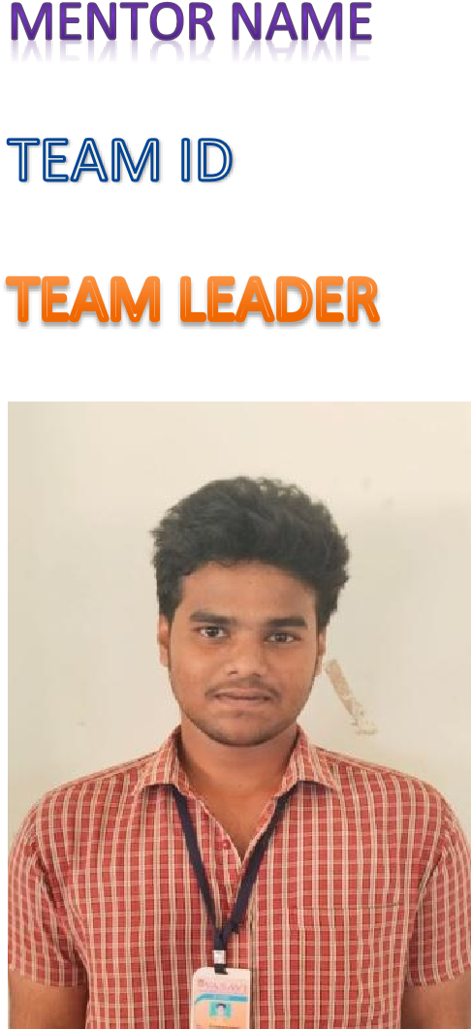**SRI.L.LAKSHMINARYANA**
* LTVIP2024TMID11734

*-* **K.YESWANTH KUMAR**.

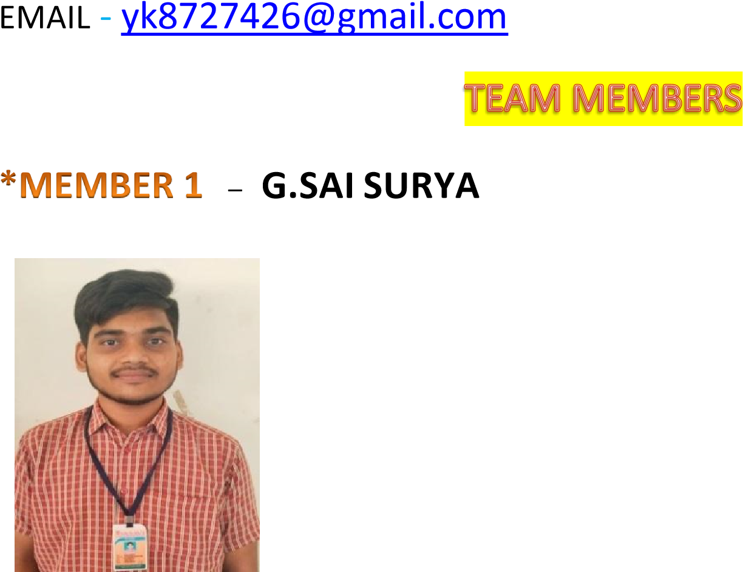

EMAIL – saisuryaguthikonda@gmail.com



-

**Y.SATYA CHARAN**



EMAIL – satyacharan1720@gmail.com

**-**

**G.RAMA SATYANARAYANA REDDY**



EMAIL **–** goluguriramureddy@gmail.com

**



**-**

**P.L.S.DURGA PRASAD**



EMAIL

EMAIL

-

plsdpyadav@gmail.com



TSK-179410



***A Developer org has all the features and licenses you need to get started with Salesforce***

Purpose and Goals: Clearly define the purpose and goals of the developer organization. This includes identifying the target audience (internal developers, external developers, partners, etc.) and outlining what you aim to achieve through the organization. Whether it's fostering innovation, building a developer community, supporting API usage, or driving developer engagement, having a clear purpose helps align efforts and resources effectively**.**

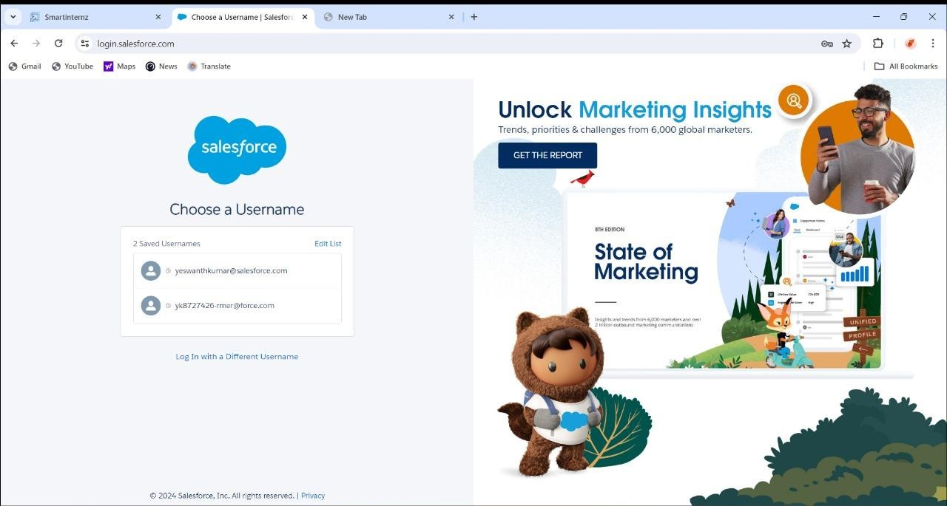

Resource Allocation and Support: Allocate appropriate resources and provide

necessary support to empower developers within the organization**.**

SETUP PAGE

*The setup page will appear as below.*

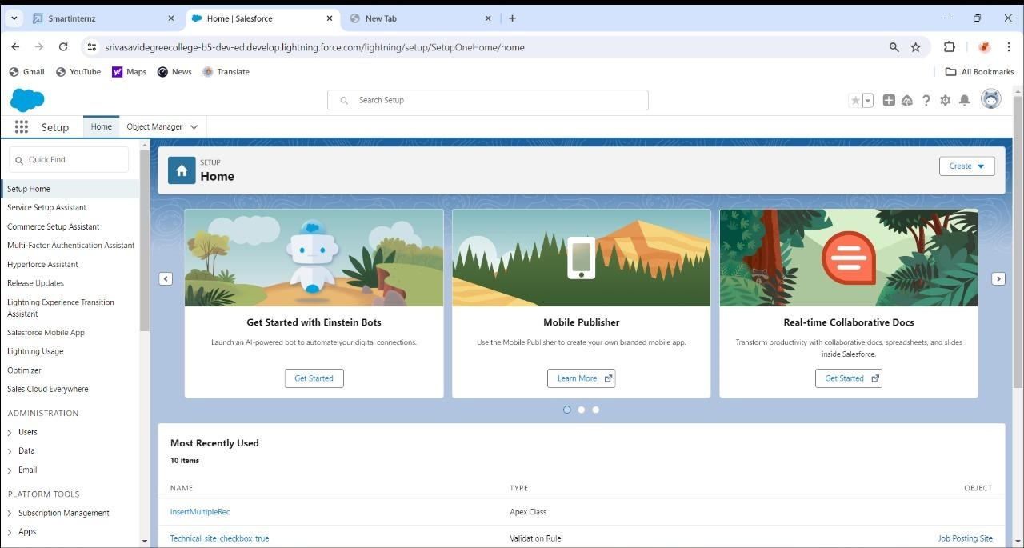

In Salesforce, the setup page is a central hub where administrators can configure and customize various aspects of their Salesforce organization.

Here's some information about the setup page:

*Navigation

*Setup Menu

*Administer

*Objects and Fields

*Develop

*Customize



Find the App: Locate the recruiting app you want to install from either Salesforce AppExchange or from a trusted third-party vendor.

Check Compatibility: Ensure that the app is compatible with your Salesforce edition and version. Review any system requirements or prerequisites specified by the app provider.

Install the Package:

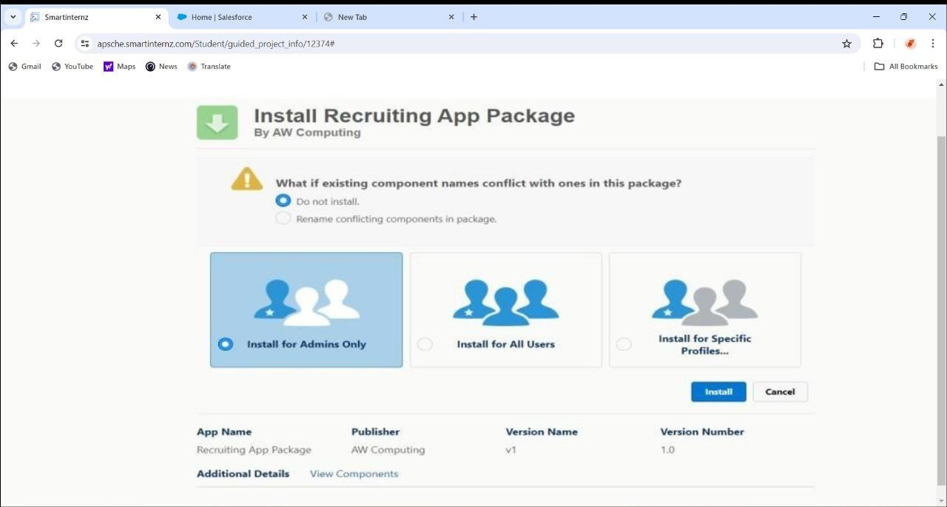

Navigate to the Salesforce Setup page by clicking on the gear icon ( ) in the topright corner and selecting "Setup."

# OBJECT

TSK - 179411

# Create A Custom Object For Job Posting Sites

A custom object for job posting sites in Salesforce can streamline recruitment processes by centralizing job postings, tracking candidate applications, and integrating with other HR systems. It enables organizations to manage job listings, monitor application statuses, and analyze recruitment metrics efficiently.

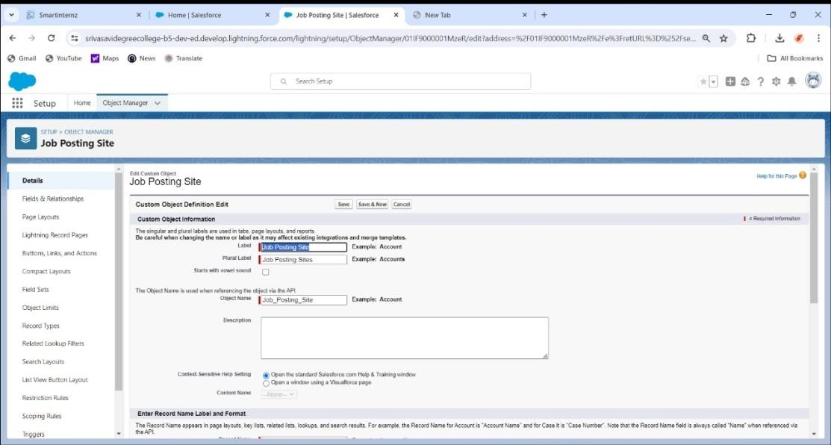

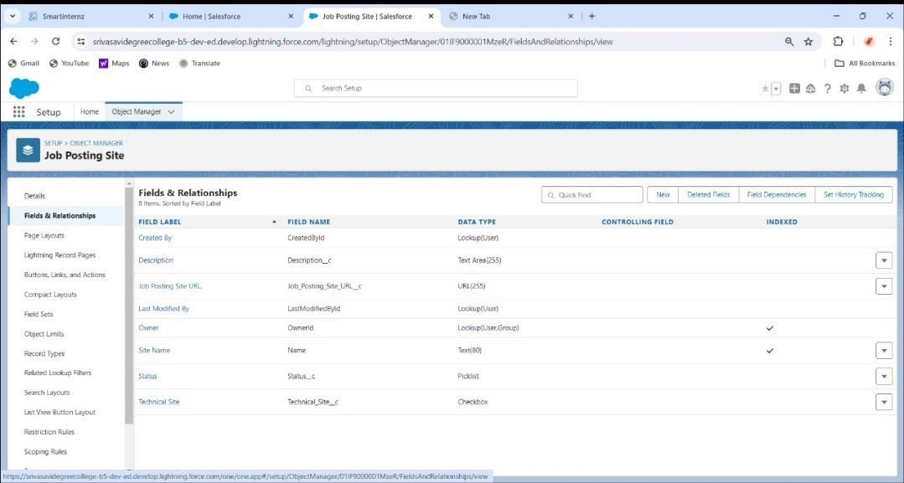



TSK - 179412

A custom object for reviews in Salesforce facilitates the collection, organization, and analysis of feedback from customers, employees, or products. It allows for tracking key metrics, sentiment analysis, and generating insights to improve products/services and enhance customer satisfaction. Integration with workflows and reporting tools enables efficient review management and actionable insights for decision-making.

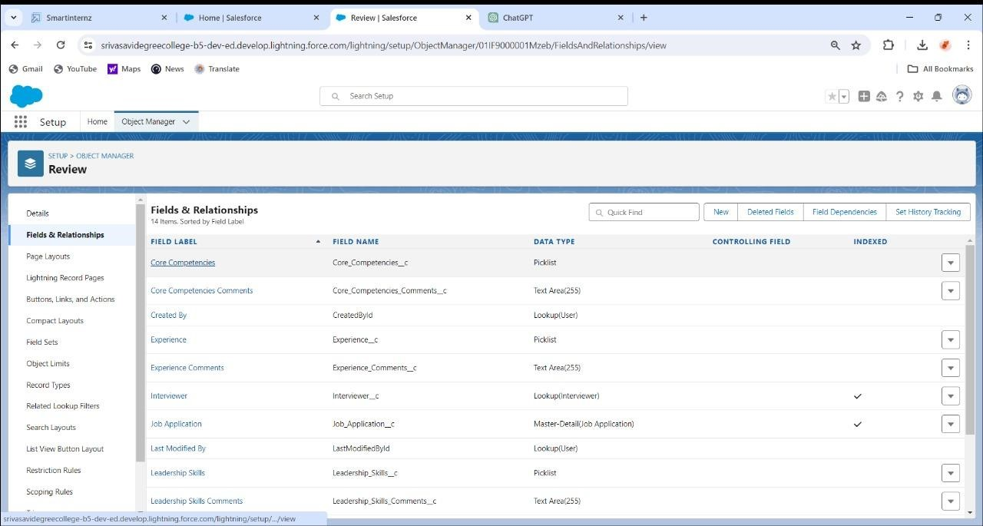

JUNCTION OBJECT

TSK - 179413

A junction object in Salesforce establishes a many-to-many relationship between two objects by serving as a bridge. It contains two master-detail relationships, linking records of the related objects. Junction objects are commonly used in scenarios where multiple records of one object need to be associated with multiple records of another object, such as in a many-to-many relationship between Accounts and Contacts.

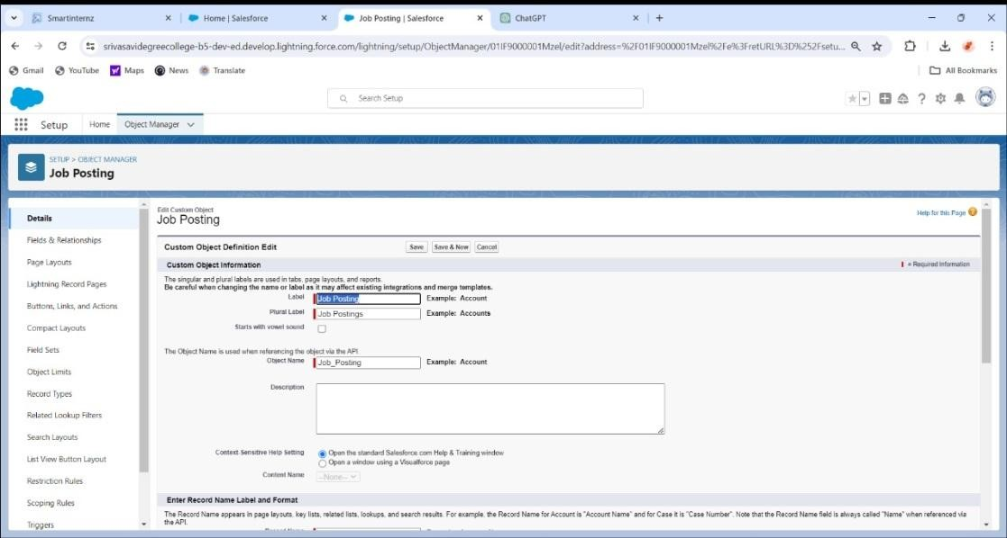

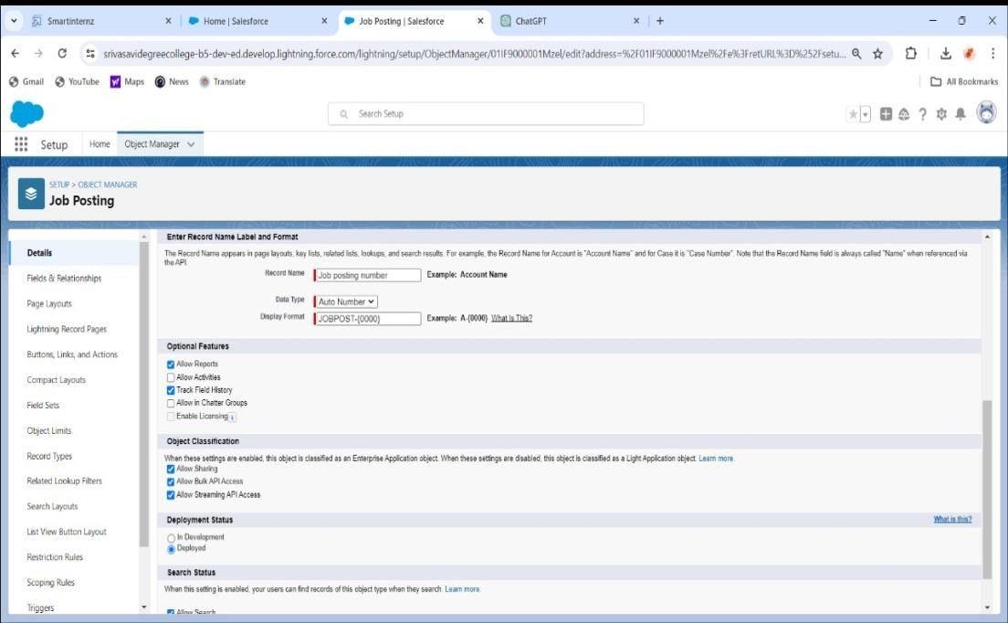

# TABS

TSK - 179414

# Creation Of Job Posting Sites Tab

Creating a "Job Posting Sites" tab in Salesforce allows users to easily access and manage information related to various job posting platforms. This tab centralizes data on job posting sites, including site names, URLs, contact information, and associated job postings, streamlining recruitment processes. Integration with custom objects, workflows, and reports enhances efficiency in managing job posting partnerships and tracking recruitment efforts.

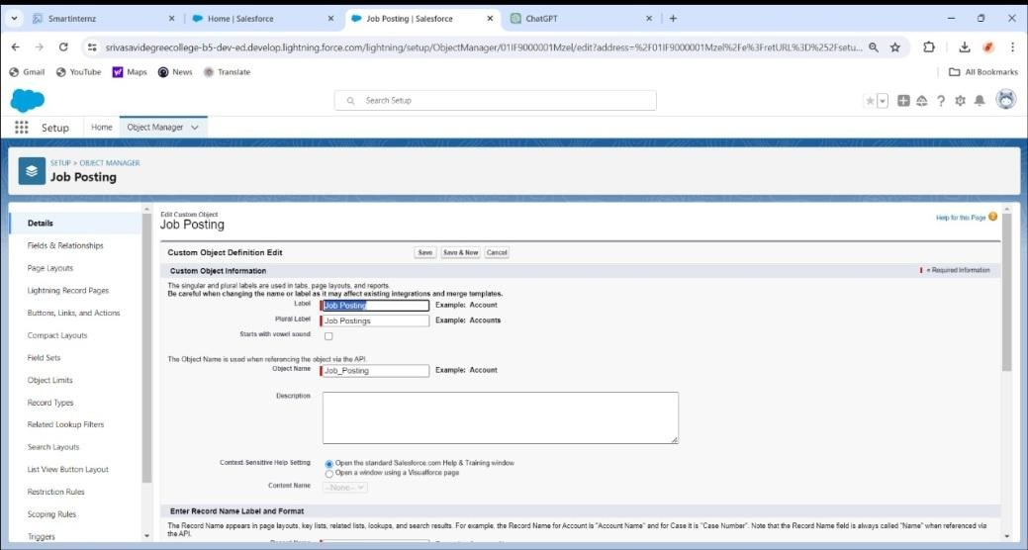

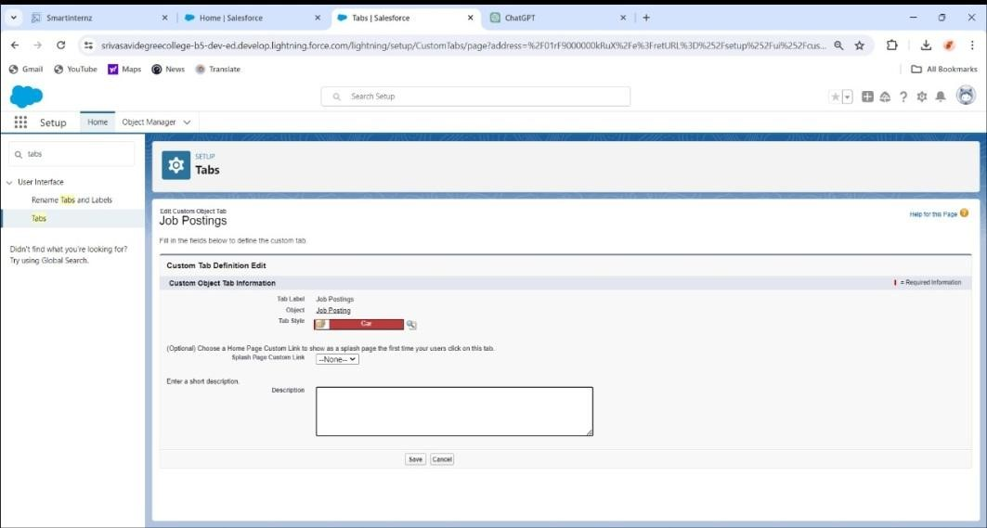



TSK -179415

Creating a "Reviews" tab in Salesforce provides a dedicated space for managing feedback and evaluations from customers, employees, or products. This tab enables easy access to review records, including ratings, comments, and sentiment analysis, facilitating data-driven decision-making and actionable insights. Integration with workflows and reports enhances review management and analysis, improving overall performance and customer satisfaction.

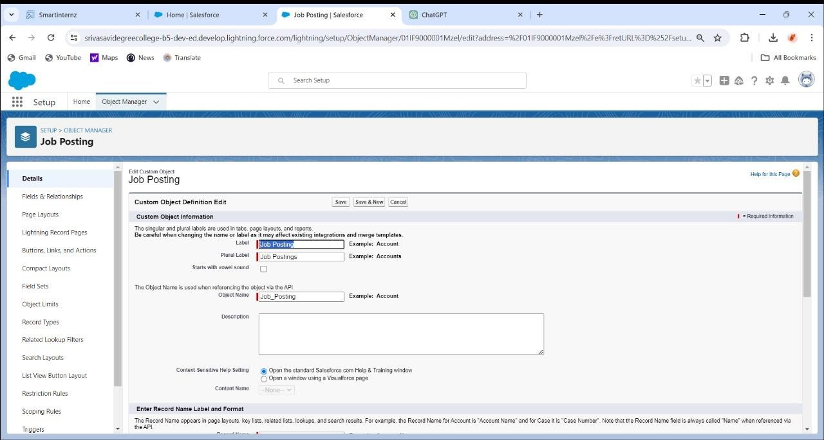

CREATION OF JOB POSTING TABS

TSK - 179416

Creating job posting sites within Salesforce can be achieved by leveraging its capabilities to customize and build applications. Here's a high-level overview of how you might approach it:

1. *Define Requirements*: Understand the requirements for your job posting site. Consider features like user authentication, job posting forms, search functionality, applicant tracking, etc.

2. *Custom Objects*: Create custom objects to represent entities such as Job Postings, Applicants, Companies, etc.

3. *User Interface*: Design the user interface using Salesforce's Lightning App Builder to create custom pages, components, and layouts.

4. *Automation*: Utilize Salesforce automation tools like Process Builder, Flow, or Apex triggers to automate processes such as sending email notifications, updating records, etc.

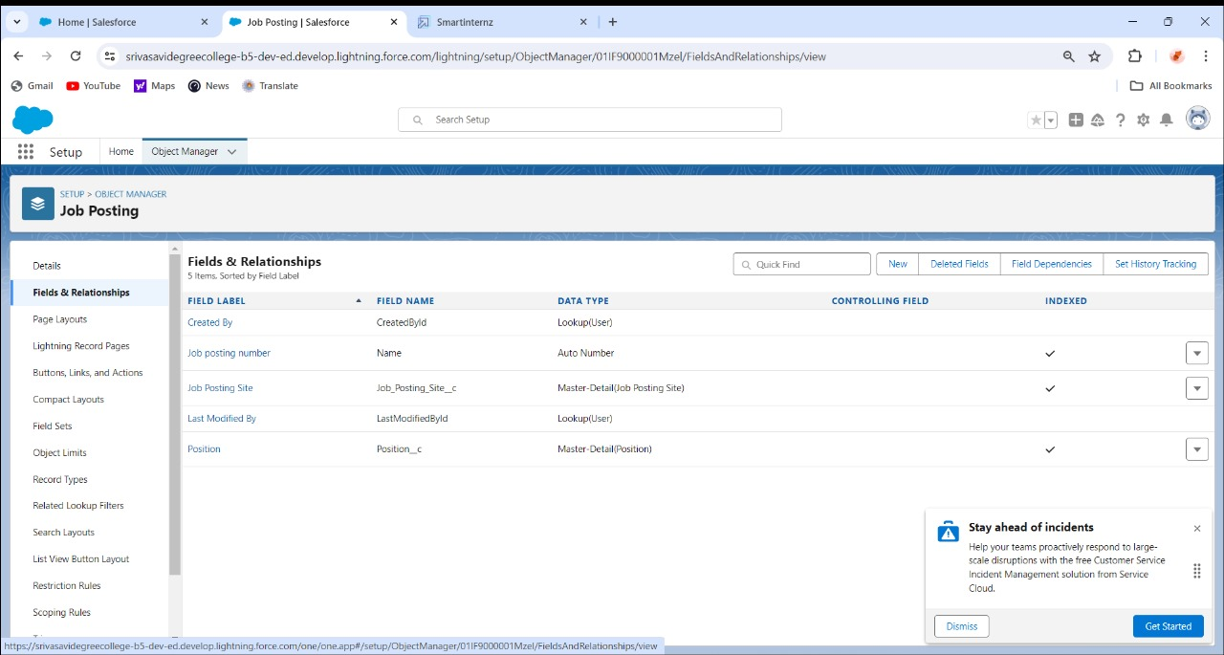

TSK – 179417 LIGTHNING APP

## Adding Job Posting Sites Tab

Adding a "Job Posting Sites" tab in Salesforce streamlines recruitment efforts by centralizing information about various job posting platforms. This tab enables easy access to site details such as names, URLs, contacts, and associated job postings, facilitating efficient partnership management. Integration with custom objects and reports enhances visibility and tracking of job posting site data, optimizing recruitment strategies.

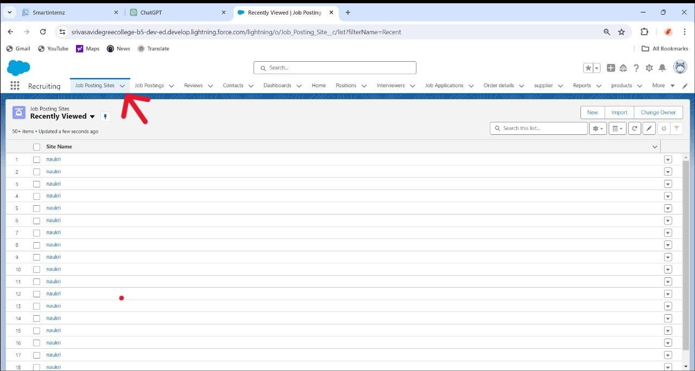

TSK - 179418 FIELDS AND RELATIONSHIPS

**Create New Field For Job Posting Site**

Creating a "Job Posting Site" field in Salesforce allows users to associate job postings with specific posting platforms, enhancing organization and categorization. This custom field captures crucial information such as site name, URL, or identifier, facilitating streamlined management and analysis of recruitment efforts. Integration with workflows and reports enables efficient tracking of job postings across different platforms, optimizing recruitment strategies.

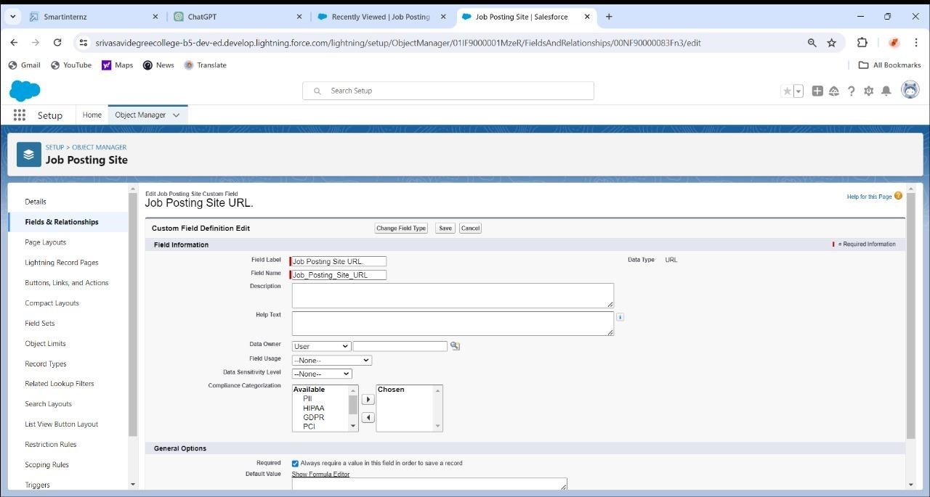

TSK – 179419



Establishing relationships for job postings in Salesforce enables effective linking between job postings and related entities, such as job applicants or job posting sites. These relationships streamline recruitment processes, allowing for easy tracking of candidate applications, site partnerships, and associated data. Integration with automation tools and reporting functionalities enhances visanalysis, optimizing recruitment strategies and decision-making

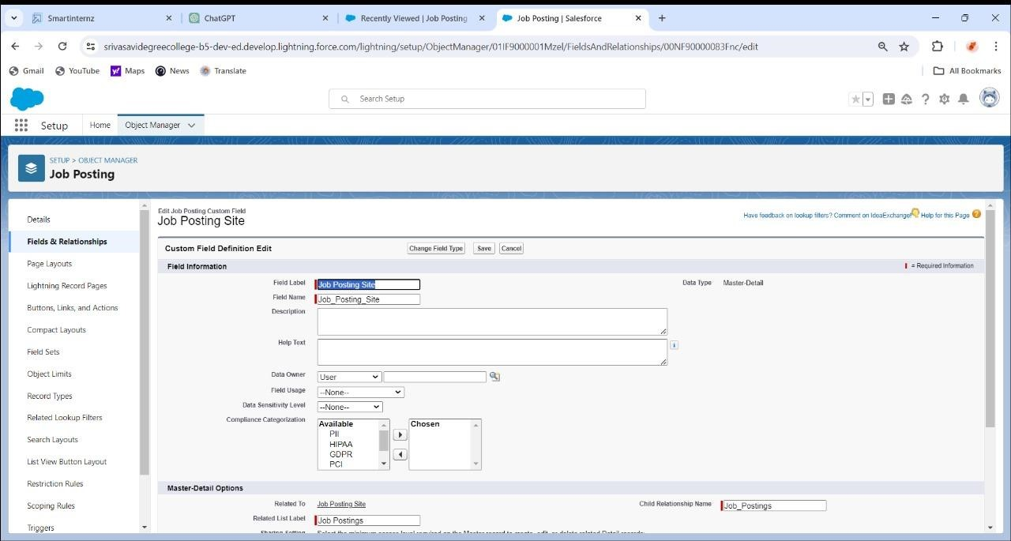

TSK – 179420



Introducing a "Review" field in Salesforce allows for systematic collection and analysis of feedback, enhancing customer insights and satisfaction. This custom field captures important details such as review ratings, comments, and timestamps, facilitating informed decisionmaking and targeted improvements. Integration with workflows and reports empowers efficient review management and performance tracking, driving continuous enhancement of products or services.

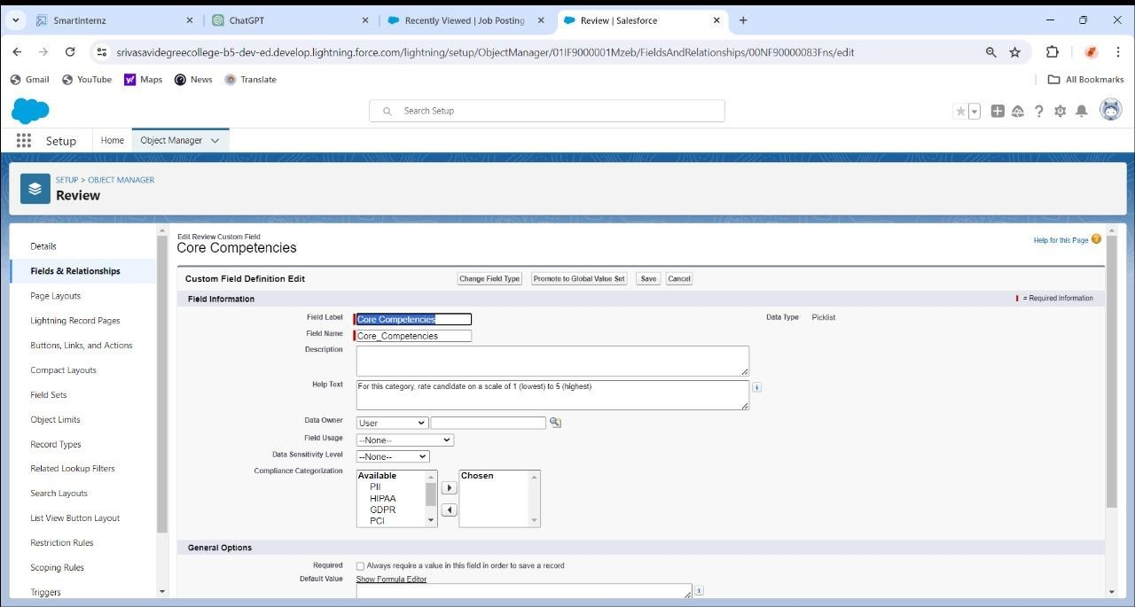

# PAGE LAYOUT

TSK - 179421

# Modifying The Page Layouts

Modifying page layouts in Salesforce enables customization of user interfaces to align with specific business needs and workflows. This includes rearranging, adding, or removing fields, related lists, and components to optimize user experience and productivity. Integration with profiles and record types ensures tailored experiences for different user roles and scenarios, enhancing efficiency and usability.

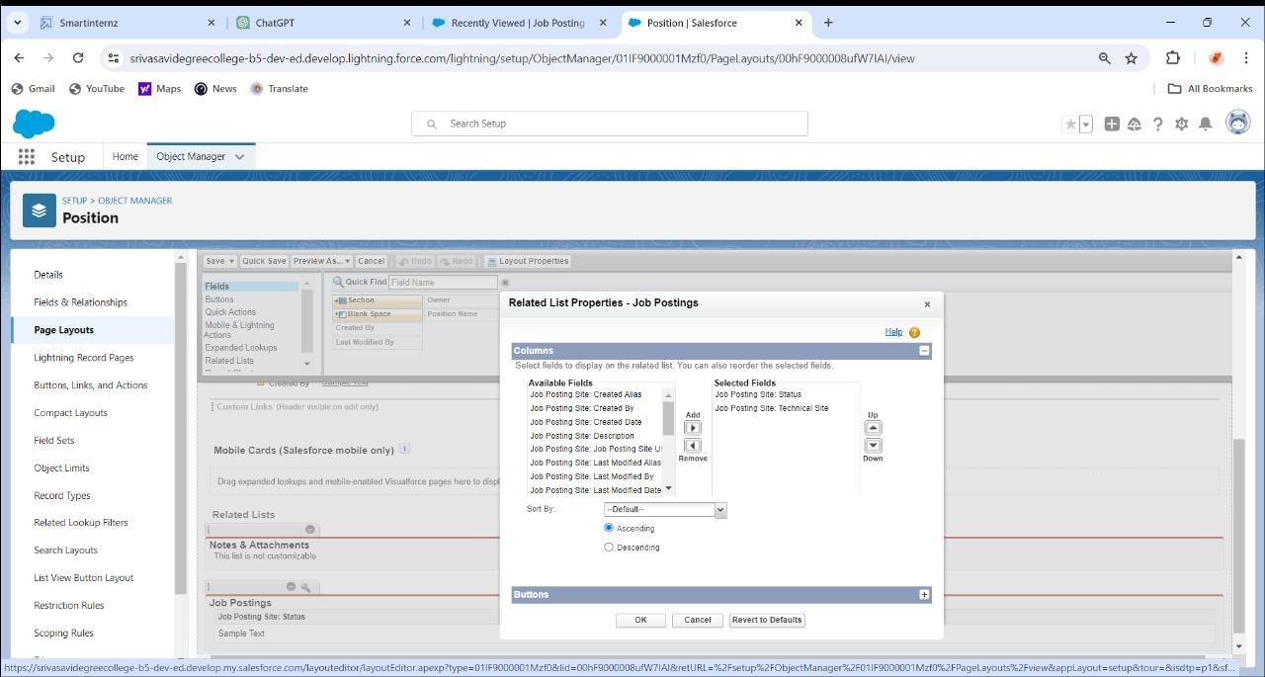

TSK - 179422



Creating a page layout for the Review object in Salesforce facilitates efficient data entry and review management. This layout organizes fields and related lists to streamline the review process, ensuring essential information such as ratings, comments, and reviewer details are easily accessible. Integration with record types enables customized layouts for different review types or stages, optimizing user experience and data accuracy.

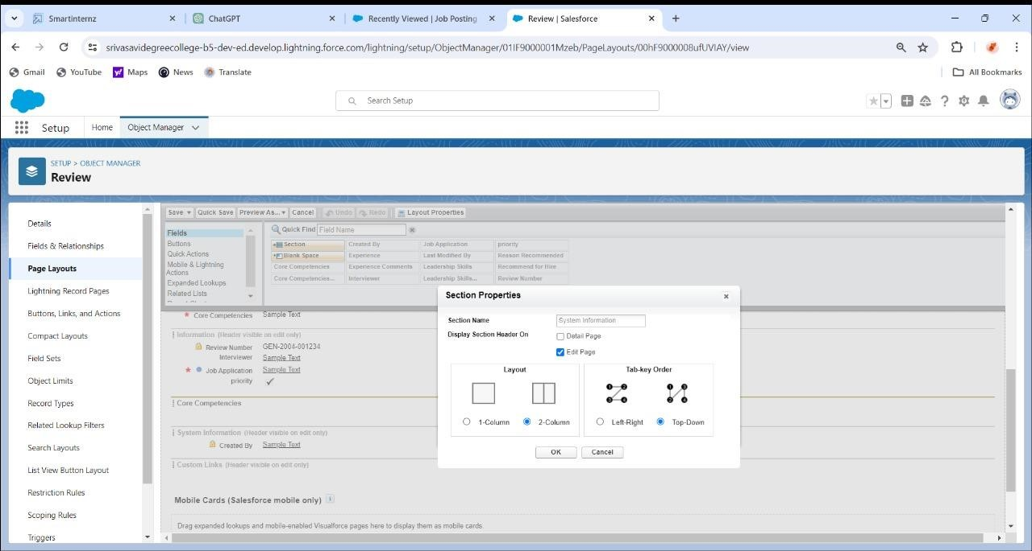

TSK – 179423



# Creating A Validation Rule

Specify the field or fields to be validated and establish the conditions for acceptance or rejection.

Test the rule thoroughly with representative data samples to ensure it effectively identifies errors or inconsistencies.

Document the validation rule comprehensively, including its purpose, conditions, and potential impacts, for future reference and maintenance.

Document the validation rule comprehensively, including its purpose, conditions, and potential impacts, for future reference and maintenance.

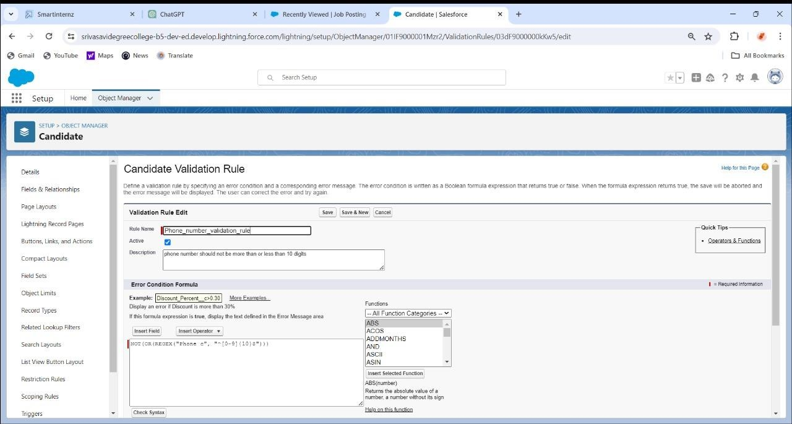

**Create A Validation Rule For Technical Site (Checkbox Is Equal To True)**

TSK - 179424

Rule name: Technical site checkbox true.

Active: checked

Description: Technical site checkbox should be check.

Under Error Condition Formula: write the condition using insert field, insert operator, insert function Technical_Site c != TRUE

Using check syntax: check if the formula you entered is valid or not.

Error Message: Please select check box of technical site.

Error location: select field (Technical site).

Save.

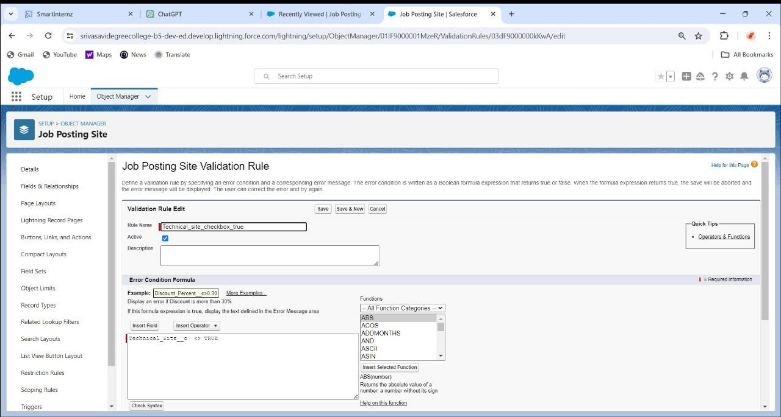

TSK – 179425



# Creation On Profile

*To create a validation rule in Salesforce for a profile, follow these steps:

*Access Setup: Log in to your Salesforce account and navigate to the Setup page.

*Open Object Manager: In the Quick Find box, type "Object Manager" and select it.

*Choose Object: Select the object (e.g., the object where the checkbox field resides) for which you want to create the validation rule.

*Validation Rules: In the left pane, under "Validation Rules," click on "New Validation Rule."

*Define Criteria: Enter a name and description for the validation rule. In the formula editor, write the validation rule formula.

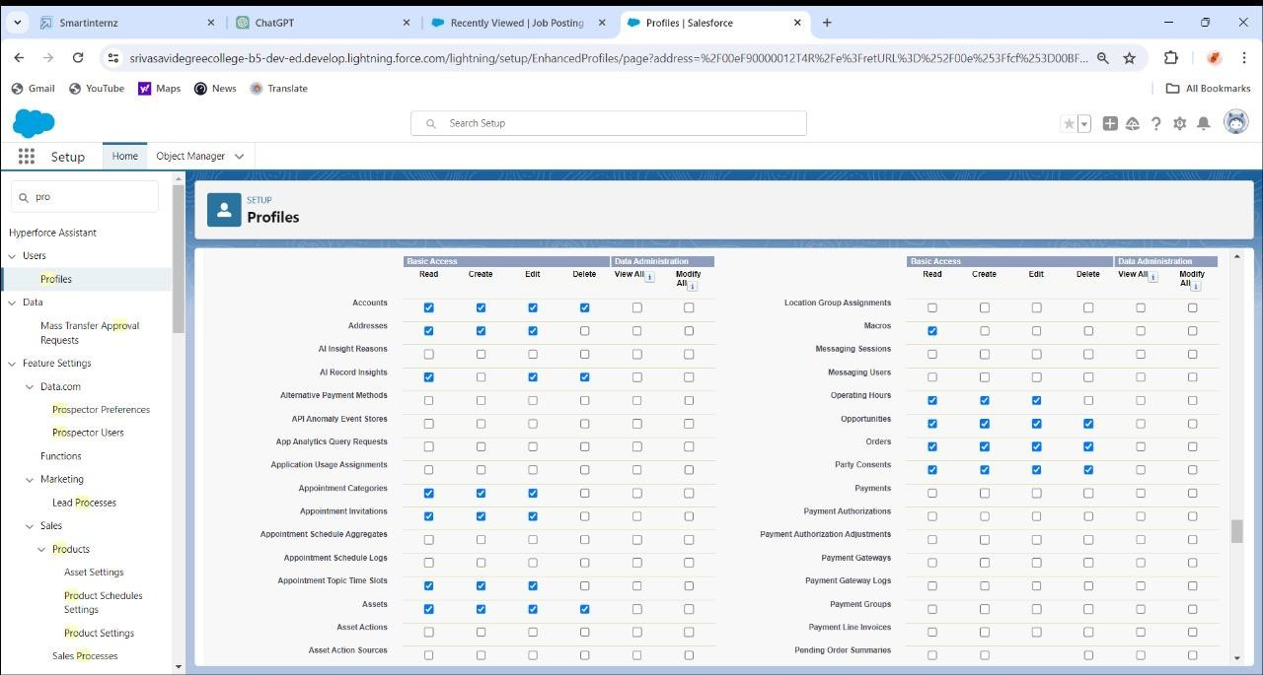

## Create A Profile With The Profile Name As “HR Profile”

TSK - 179426

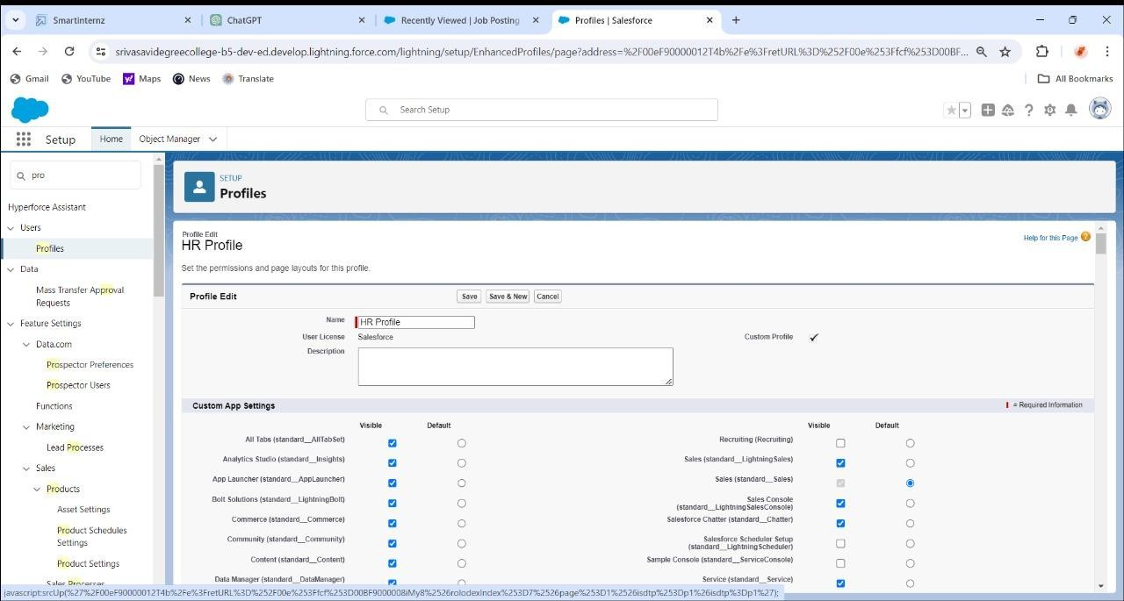

To create a profile in Salesforce named "HR Profile," follow these steps:

*Access Setup: Log in to your Salesforce account and navigate to the Setup page.

*Profiles: In the Quick Find box, type "Profiles" and select it.

*New Profile: Click on the "New Profile" button.

*file Settings: Enter "HR Profile" as the profile name.

*Permissions: Set the appropriate permissions for the profile based on the requirements of your HR users. This may include object permissions, field permissions, and other settings related to data access and functionality.

*Save: Once you have configured the profile settings, click "Save" to create the "HR Profile."

*Assign Users: After creating the profile, assign users to it by editing their user records and selecting the "HR Profile" from the Profile dropdown menu.

*Test: Test the profile by logging in as a user assigned to the "HR Profile" to ensure that the permissions and settings are configured correctly.

TSK – 179427



Creating A User



To create a user in Salesforce, follow these steps:

Access Setup: Log in to your Salesforce account and navigate to the Setup page.

Users: In the Quick Find box, type "Users" and select it.

New User: Click on the "New User" button.

User Information: Fill in the required user information, including First Name, Last Name, Email, Username, Role, Profile, etc.

Role Assignment: Assign a role to the user if applicable. Roles define the level of access a user has to records in Salesforce.

Profile Assignment: Assign a profile to the user. Profiles determine the permissions and settings available to the user.

Save: Once you have entered all the necessary information, click "Save" to create the user.

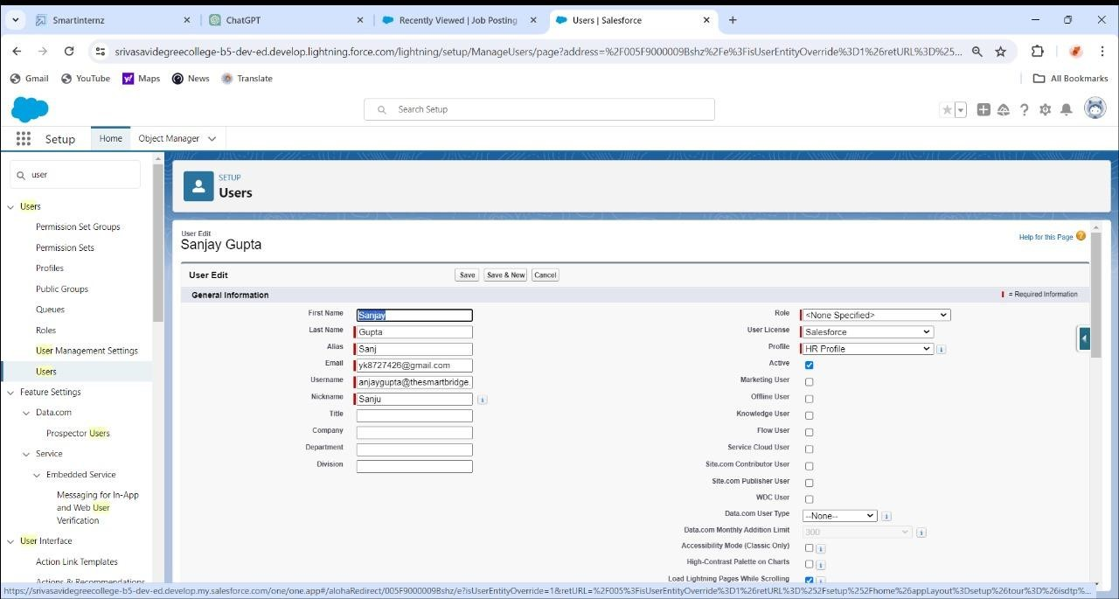

## Create Another User

TSK - 179427

To Create a user with a username as “Abhilash Garapati”, and assign him the interviewer profile.

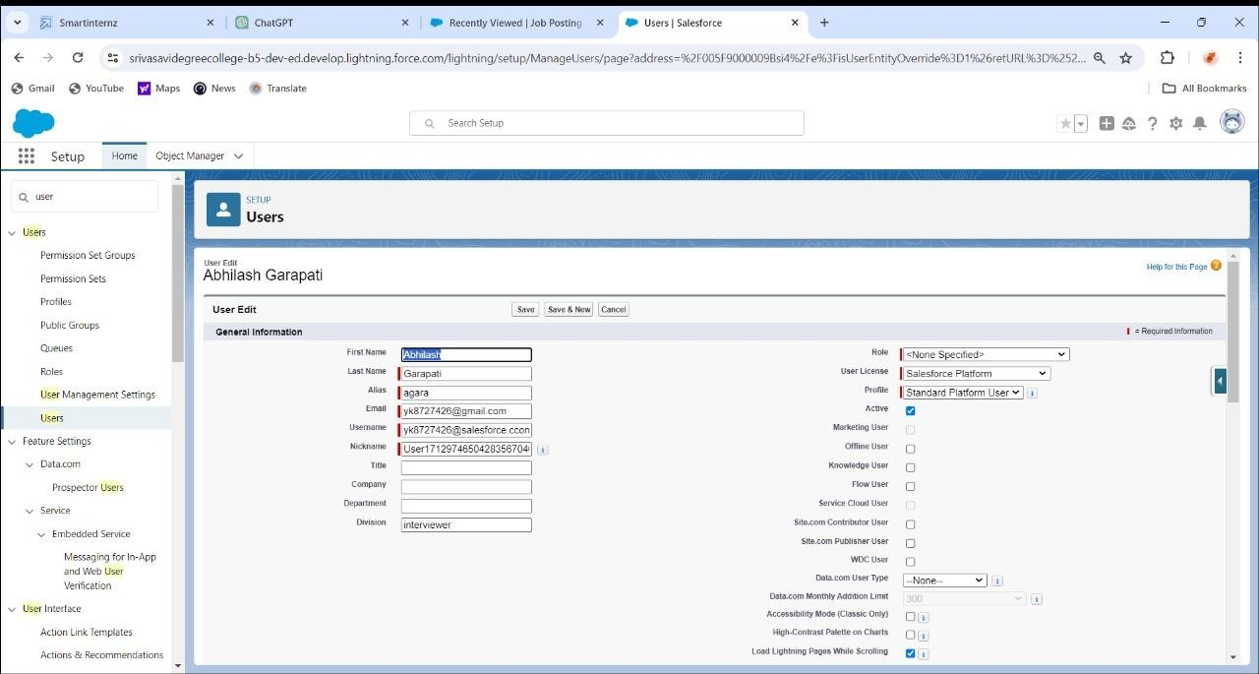

*Access Setup: Log in to your Salesforce account and navigate to the Setup page.

*Users: In the Quick Find box, type "Users" and select it.

*New User: Click on the "New User" button.

*User Information:

First Name: Abhilash

Last Name: Garapati

*Then Save It.

TSK – 179429



# Creating A Permission Set

New Permission Set: Click on the "New" button to create a new permission set.

Permissions: Click on the "Permissions" tab to configure the permissions for the permission set

License: Select the appropriate license if required. This determines the features and functionalities available to users assigned this permission set.

Save: Once you have configured the permissions, click "Save" to create the permission set.

Assign Users: After creating the permission set, assign users to it by clicking on the "Manage Assignments" button and then clicking "Add Assignments". You can assign users individually or by using a permission set group.

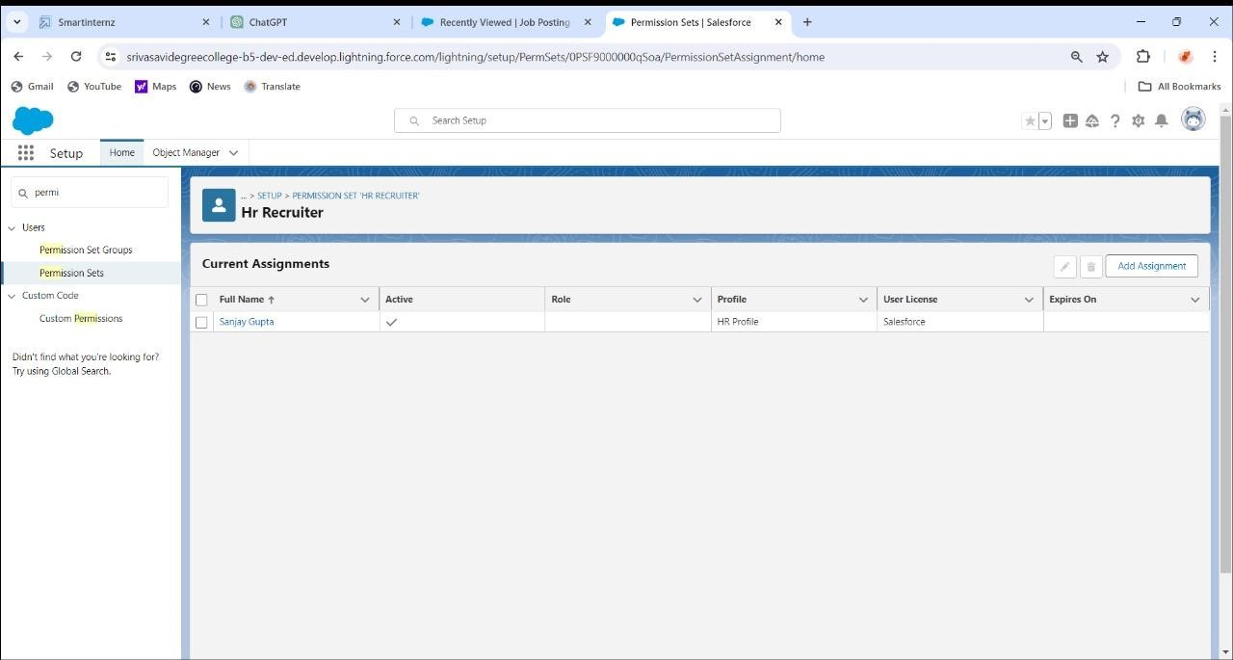

TSK – 179430



# Create a record (positions)

*Click on App Launcher on left side of screen.

*Search Recruiting & click on it.

*Click on Positions Tab.

*Click new and fill details & Save

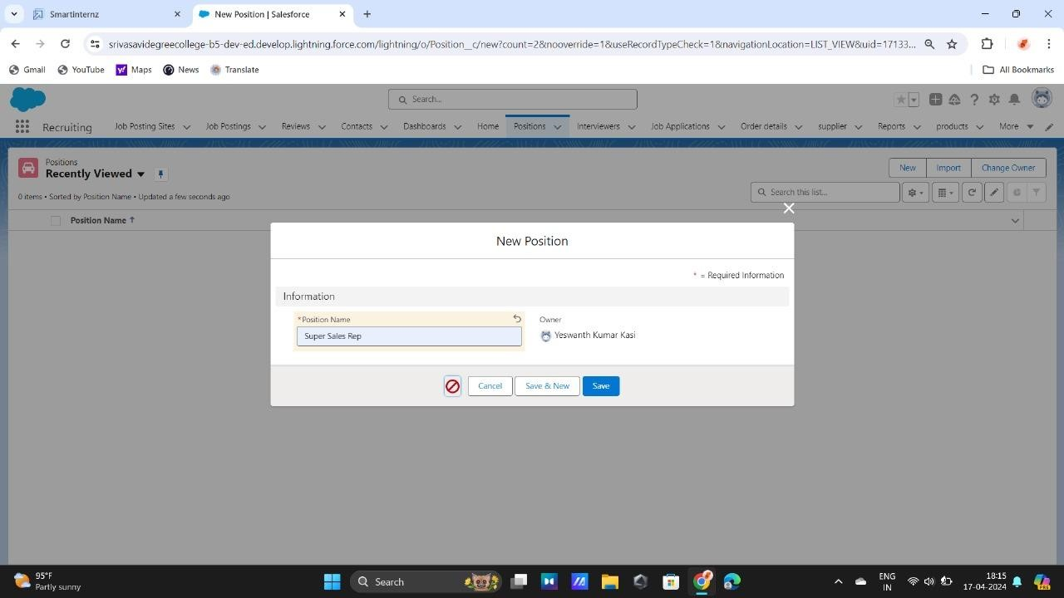

## View a record (positions)

TSK - 179431

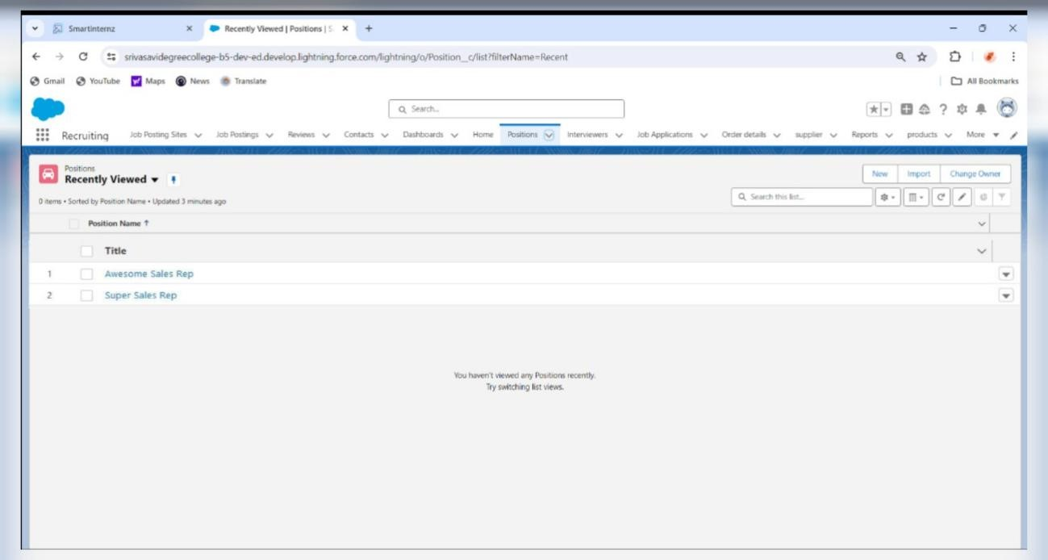

*Click on App Launcher on left side of screen.

*Search Recruiting & click on it.

*Click on Positions Tab.

*Click on any record name. you can see the details of the Positions.

TSK – 179432

Delete a Record (positions)

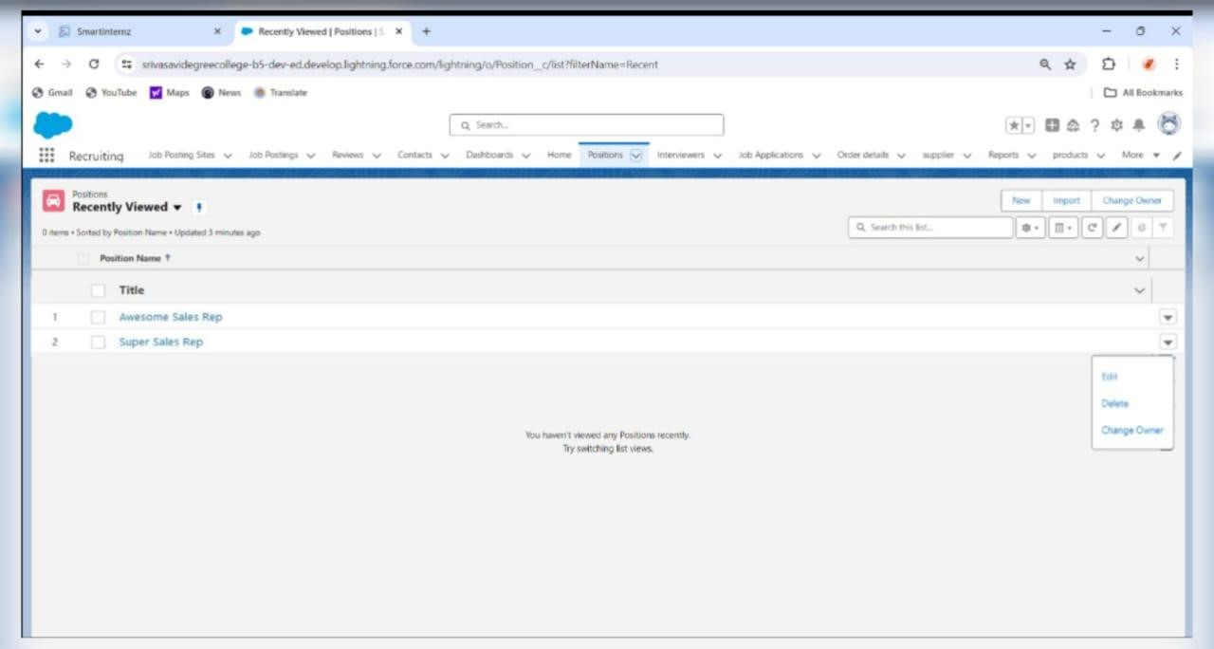

*Click on App Launcher on left side of screen.

*Search Recruiting & click on it.

*Click on Positions Tab.

*Click on Arrow at right hand side on that Particular record.

*Click delete and delete again.

# REPORTS

TSK - 179433

# Create a Report

*Navigate to the Report Builder *Log in to your Salesforce account.

*Go to the "Reports" tab.

*Choose Report Type:

*Click on the "New Report" button.

*Select Fields:

*Choose the fields you want to include in the report. You can drag and drop fields from the left panel to the report builder.

*Save and Run the Report:

*Once you're satisfied with the report setup, click on "Save & Run" to generate the report.

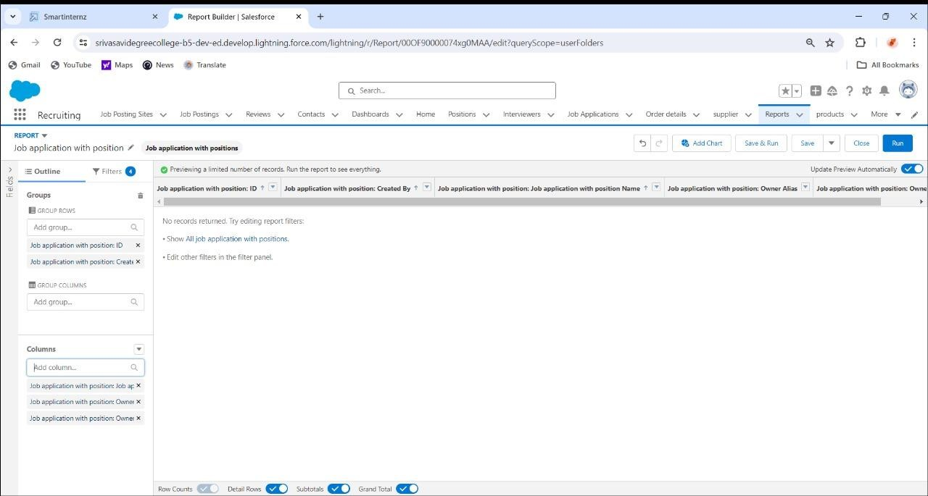

TSK - 179434

## Create a Report For Job Posting Sites With Job Positions And Positions

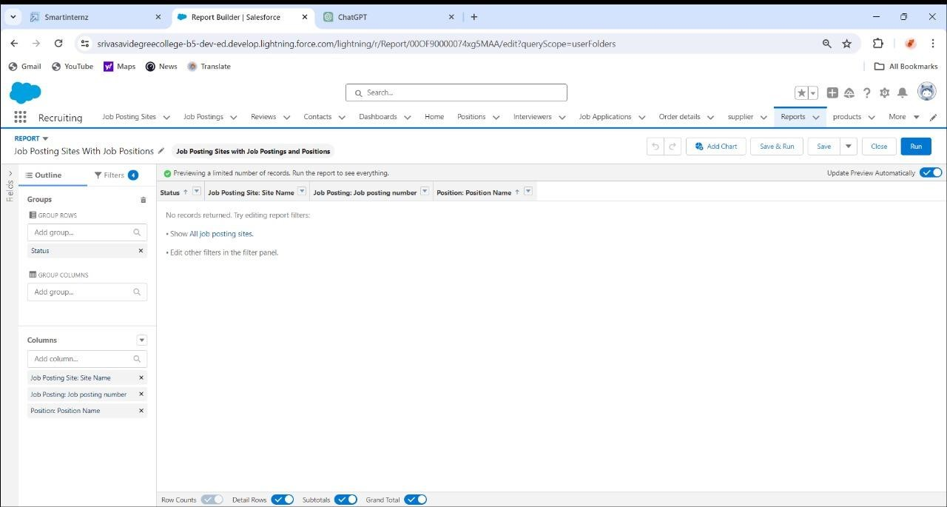

*Log in to your Salesforce account.

*Go to the "Reports" tab.

*Choose the fields you want to include in the report.

*Customize the report layout by adjusting column widths, rearranging fields, and adding headers or footers as needed.

*Save and Run the Report:

*Once you're satisfied with the report setup, click on "Save & Run" to generate the report.

# DASHBOARD

TSK - 179435

# Create a dashboard

* Click the Dashboards tab.
* Click New Dashboard.
* Name the dashboard Job application with position and click Create.
* Click +Component.
* Select Job application with position and click Select.
* Select the Vertical Bar Chart component and click Add.
* Click Save and then Done.

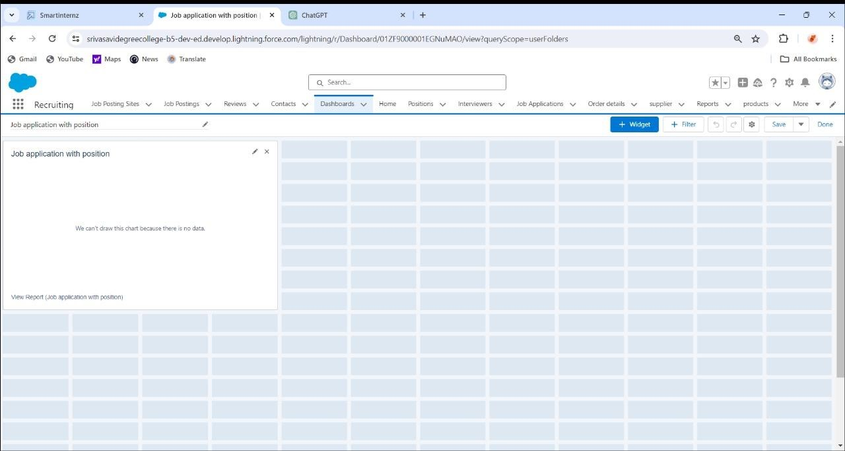

TSK – 179436 

# Report



* Click on App Launcher on left side of screen.
* Search Recruiting & click on it.
* Click on Reports Tab.
* Click on Job application with position & see records

TSK – 179437 DASHBOARD

* Click on App Launcher on left side of screen.
* Search Recruiting & click on it.
* Click on Dashboard Tab.
* Click on Job application with position & see records

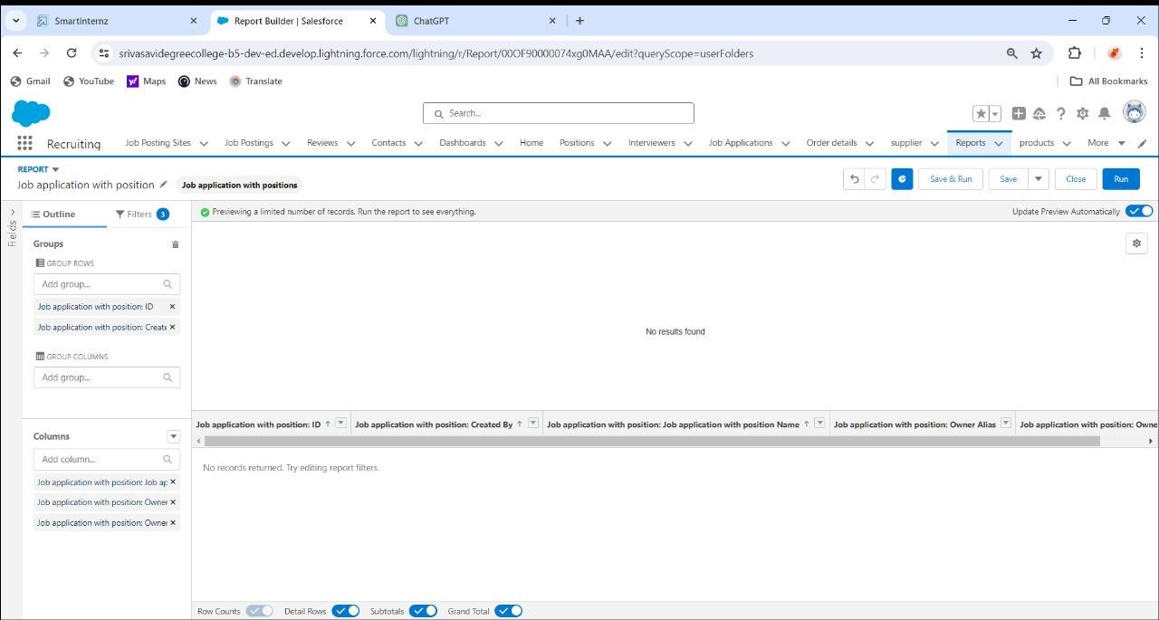

TSK – 179438



**Creation of**

**the**

**Trigger**

Use Case:

HR is struggling!! Not knowing whom to hire on priority so she contacted the developer. Now the developer made the HR task bit easy with this chages . There is the Review__c Object and there is 2 field priority and Recommended for Hire(CheckBox) so condition is like if suppose if we checked the checkbox than priority should be high

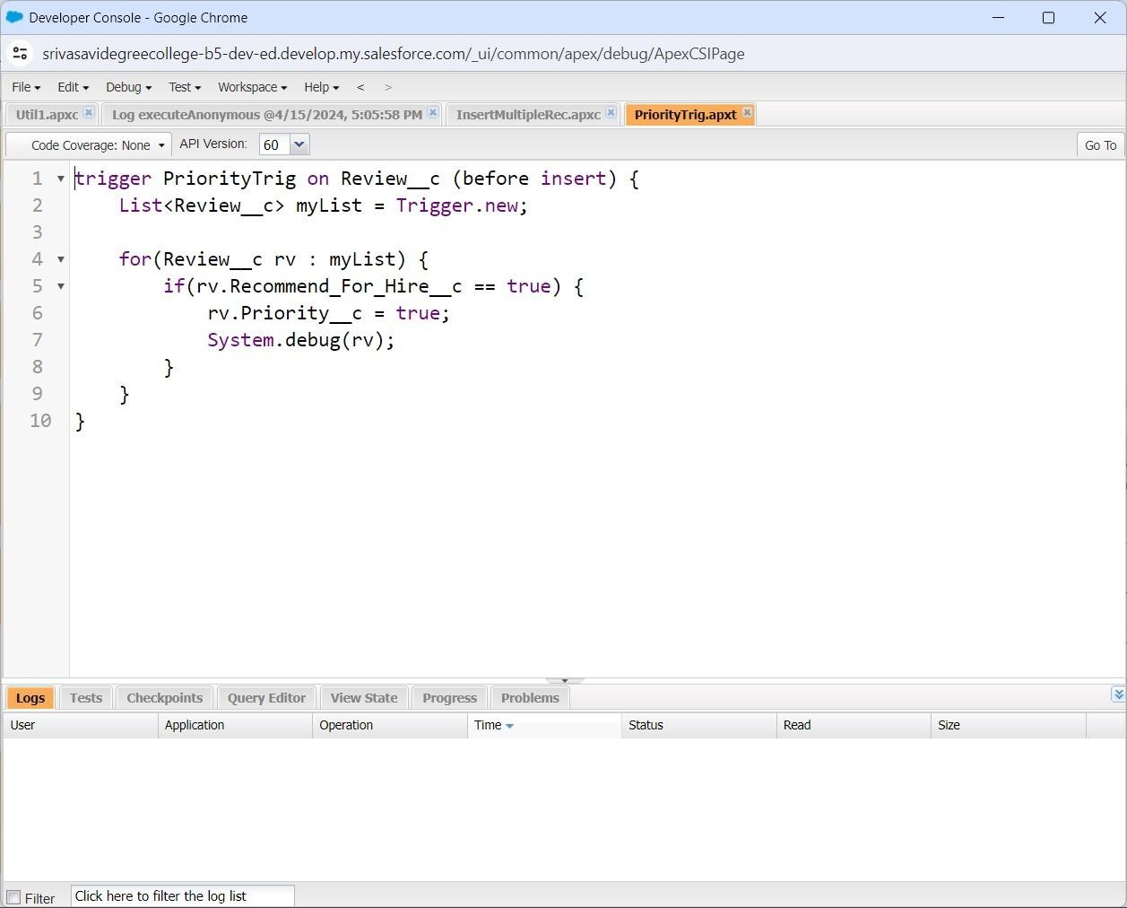

TSK – 179439 

### Create the DML Insert for the Job Posting Site

The HR Manager was looking in the Application and just checking how many candidates have applied for the job and he came to know that there are too many Candidates who applied for the job. So what the HR manager is Doing whenever there are too many Records he stores the information in the Excel sheet as per the month's Records. So he went to the Developer and asked to fetch the Record of the Job Posting Site. So This Task will be Executed with Apex Batch

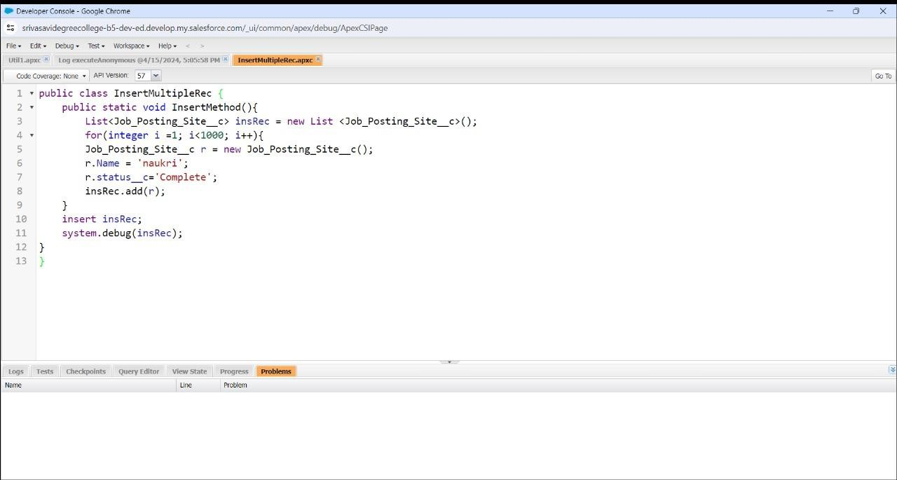

### TSK - 179440 Create the Batch

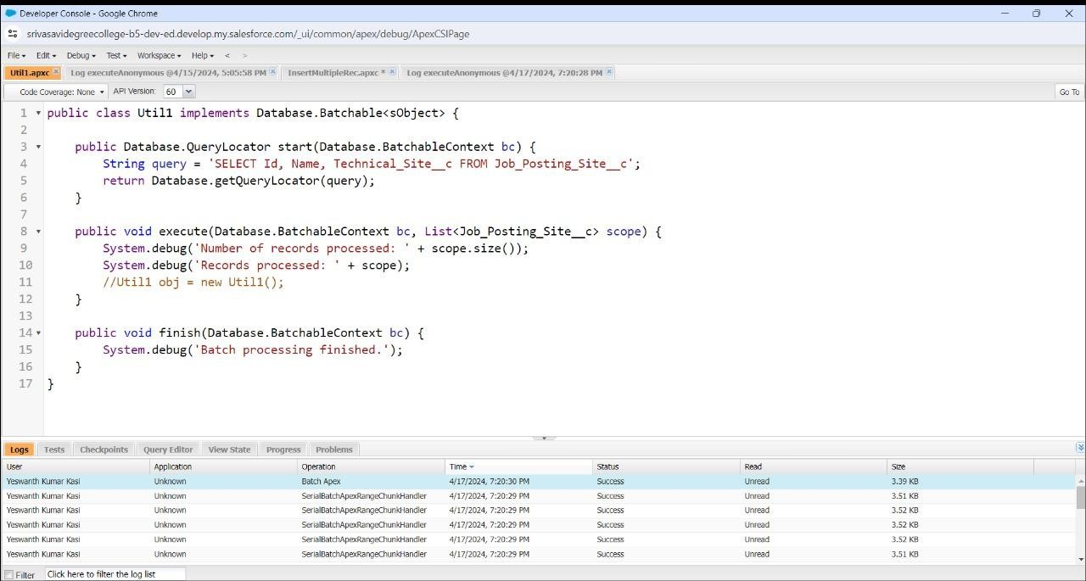

* Write a class that implements the Database.Batchable interface.

This class will contain the logic to process your data in batches.

* Define the start, execute, and finish methods required by the interface.
* In the start method, query for the records you want to process.
* In the execute method, process the records in the batch.

TSK – 179441

CHECK THE BATCH

* Click on the gear icon
* click on setup
* Click on the home button and search for
* Apex Jobs than you can see the success of the chunks it run 200 batch for the total record

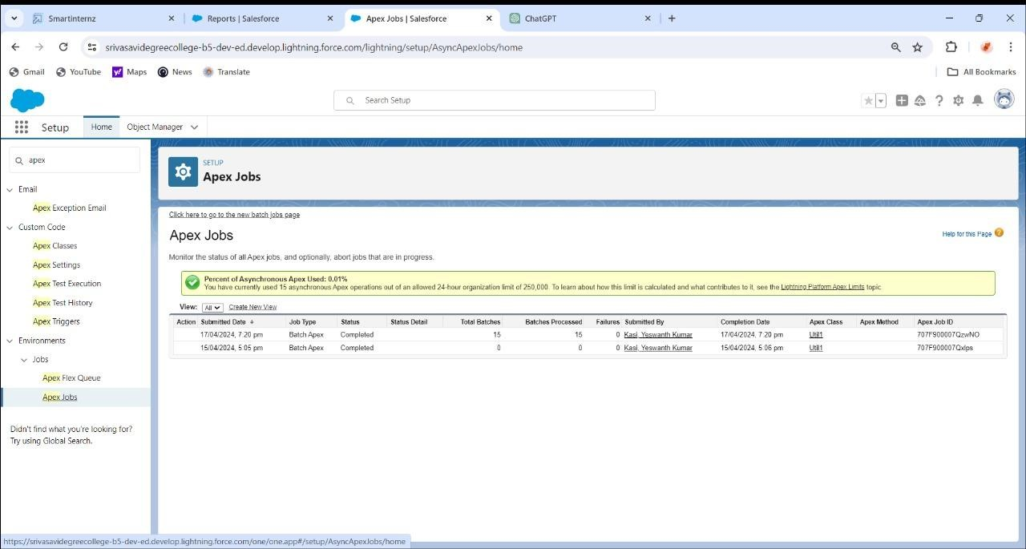

COMMENTS:

I HAVE LEARN SO MANY CONCEPTS ABOUT SALES FORCE ADMIN/DEVELOPER & ME AND MY TEAM CAN LEARN HOW TO TACKLE DO IT TRAILMIX MODULES AND IT IS VERY INTERESTING TO DO IT IN STEP TO STEP AND FINALLY IN PROJECT WE WILL DO IT PROJECT. THANKS TO REPECTED PRINCIPAL SIR OF MY COLLEGE SRI M.RAMA KRISHNA SIR FOR COOPERATE AND SUPPORTING DURING INTERNSHIP PROGRAM AND A SPECIAL THANKS TO MY RESPECTED

MENTORSRI L.LAKSHMI NARAYANA SIR FOR GUIDING MY TEAM IN PROJECT AND DO IT WELL IN WORK.

THANK YOU, SMART BRIDGE

------KASI YESWANTH KUMAR

TEAM LEADER